BIT 4107 — MOBILE APPLICATION DEVELOPMENT
Week 7: Data Storage and Database Integration
Class Tasks Report

Student Name | NOELLE BLESSING
Admission Number | BIT/2024/73309
School/Faculty | Mount Kenya University
Programme | MOBILE APPLICATION AND DEVELOPMENT
Academic Year / Semester | 2025/2026 — Year 3 Semester 2
Lecturer | Mr. Nyoro
Project | Intelligent Retail Analytics Engine

Task 1: Storage Method Comparison
Storage Method | Advantages | Disadvantages
Shared Preferences | Very simple to implement; ideal for small key-value data such as settings, currency, and business name; fast read/write | Cannot store structured or relational data; not suitable for large datasets; no querying capability
SQLite | Supports structured relational data with tables and relationships; supports complex queries (SQL); works fully offline; no server required | Slightly more setup complexity than Shared Preferences; data stored only on the local device unless synced; manual schema migration needed
Firebase | Cloud-based and accessible from multiple devices; real-time sync; built-in authentication; scalable for larger user bases | Requires internet connection; can incur cost at scale; less control over data structure compared to a relational database
Internal Storage | Good for storing files such as images, PDFs, or generated reports; private to the application | Not suitable for structured/queryable data; managing many files becomes difficult; no built-in search capability

Task 2: Student Database Design
The table below shows the design for a university student management application database.

Field | Data Type | Constraint | Description
StudentID | INTEGER | PRIMARY KEY, AUTOINCREMENT | Unique identifier for each student record
Name | TEXT | NOT NULL | Full name of the student
Course | TEXT | NOT NULL | Programme the student is enrolled in
Year | INTEGER | NOT NULL | Current year of study (1–4)
PhoneNumber | TEXT | UNIQUE | Student's contact phone number

Primary Key
StudentID is selected as the primary key because it uniquely identifies every student record and never changes, even if the student's name, course, or phone number is updated. Using an auto-incrementing integer also makes lookups and joins with other tables (such as an Attendance table) fast and efficient.

Task 3: Mini Project — Continuation of the Intelligent Retail Analytics Engine
As instructed, this task continues directly from the mobile application already being developed across the previous weeks — the Intelligent Retail Analytics Engine, a universal retail management app for small businesses. Rather than building a separate attendance application, the same persistent storage and security concepts taught in Week 7 (registration, authentication, hashing, and structured local storage) have been applied directly to the existing project.

Storage Method Selected
SQLite was selected as the primary storage method for the application, supplemented by Shared Preferences for simple settings such as currency and business name.

Why SQLite Was Selected
- The application needs to store structured, relational data — products, sales transactions, and user accounts — which Shared Preferences cannot handle.
- SQLite works fully offline, which is essential for small retail businesses in areas with unreliable internet connectivity, such as Thika CBD.
- SQLite allows fast querying of sales history to calculate real-time profit and loss figures.
- No external server or ongoing cost is required, unlike Firebase, making it sustainable for a small business owner to use long-term.

Database Structure
The application uses three core tables in its SQLite database:

Table: users

Field | Data Type | Constraint | Description
id | TEXT | PRIMARY KEY | Unique identifier for each registered operator
fullName | TEXT | NOT NULL | Full name of the operator
email | TEXT | UNIQUE, NOT NULL | Operator identifier used to log in
passwordHash | TEXT | NOT NULL | SHA-256 hashed password — the plain password is never stored
role | TEXT | NOT NULL | Access role: Merchant Console or Client View

Table: products

Field | Data Type | Constraint | Description
id | TEXT | PRIMARY KEY | Unique identifier for each product
name | TEXT | NOT NULL | Product name
category | TEXT | NOT NULL | Product category (e.g. Electronics, Food)
costPrice / sellingPrice | REAL | NOT NULL | Used to calculate profit margin automatically
stockQty | INTEGER | NOT NULL | Current stock level

Table: sales

Field | Data Type | Constraint | Description
id | TEXT | PRIMARY KEY | Unique identifier for each sale transaction
productId | TEXT | FOREIGN KEY → products.id | Links each sale to the product sold
quantitySold | INTEGER | NOT NULL | Number of units sold in this transaction
totalRevenue / profit | REAL | NOT NULL | Calculated automatically at the time of sale

Relationships
The sales table relates to the products table through a one-to-many relationship: one product can have many sale records, linked via the productId foreign key. This allows the application to calculate total revenue, total profit, and turnover rate per product by querying the sales table.

Normalization
The database follows Third Normal Form (3NF) principles. Product details (name, category, prices) are stored once in the products table rather than being repeated on every sale record. The sales table only stores a reference (productId) plus transaction-specific data, eliminating data redundancy and ensuring that updating a product's price does not require updating historical sales records.

Password Hashing Evidence
To protect operator credentials, the application hashes every password using the SHA-256 algorithm before it is stored or compared. The plain-text password is never saved in the database — only its irreversible hash is stored in the passwordHash column of the users table.

String hashPassword(String password) { final bytes = utf8.encode(password); final digest = sha256.convert(bytes); return digest.toString(); }

During login, the password entered by the user is hashed using the same function and compared against the stored hash in the database. If they match, access is granted; if not, an "Invalid security access key credentials" message is shown.

Figure 1: Register Operator Screen
The Register Operator screen captures Full Name, Operator Identifier (Email), System Access Role (Merchant Console or Client View), and Security Access Key (Password) with a confirmation field. This screen writes a new record to the users table via the insertUser() method, which rejects duplicate emails.

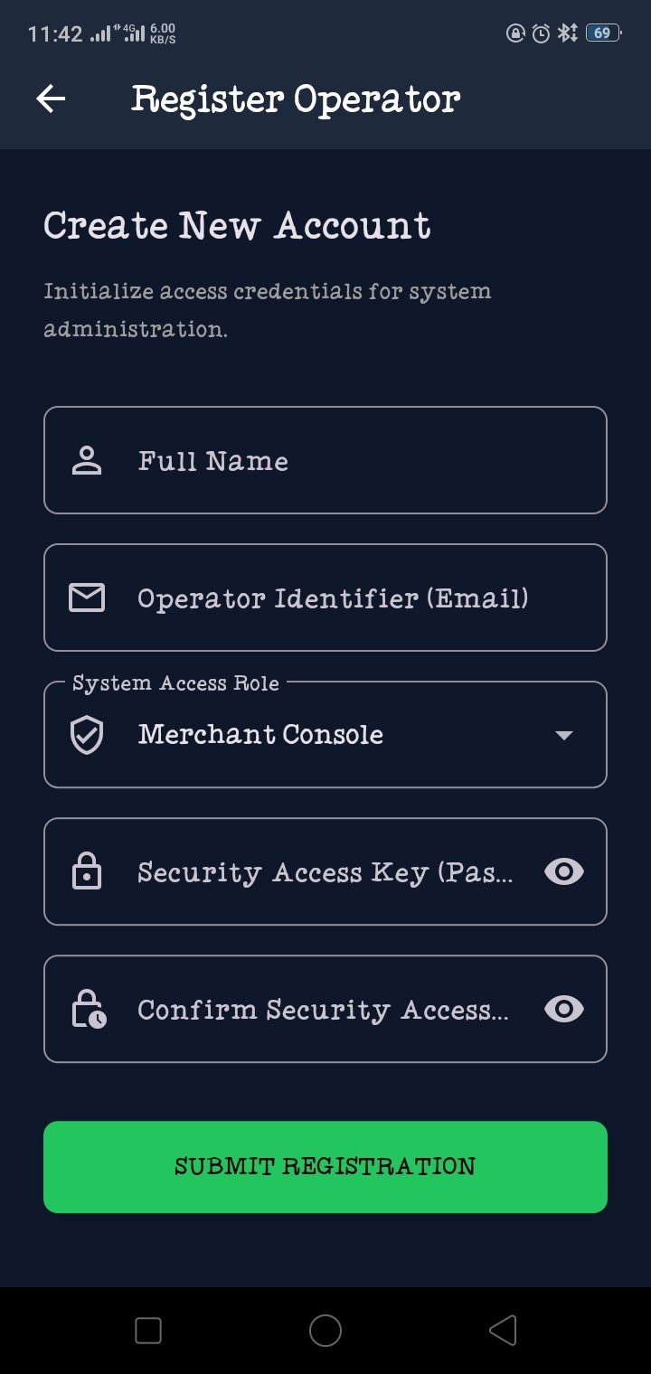
Figure 1: Register Operator screen — capturing Full Name, Operator Identifier (Email), System Access Role, and Security Access Key (Password) with confirmation field

Figure 2: Login Screen — Live SHA-256 Hash Generation
The Login screen shown below demonstrates the SHA-256 hash being generated in real time as the password is typed for the operator account lionoble20@gmail.com under the Merchant Console access mode. The generated hash (ef797c8118f02dfb649607dd5d3f8c7623048c9c063d532cc95c5ed7a898a64f) confirms the hashing mechanism is functioning correctly before the credential is ever sent for comparison against the stored hash in the database.

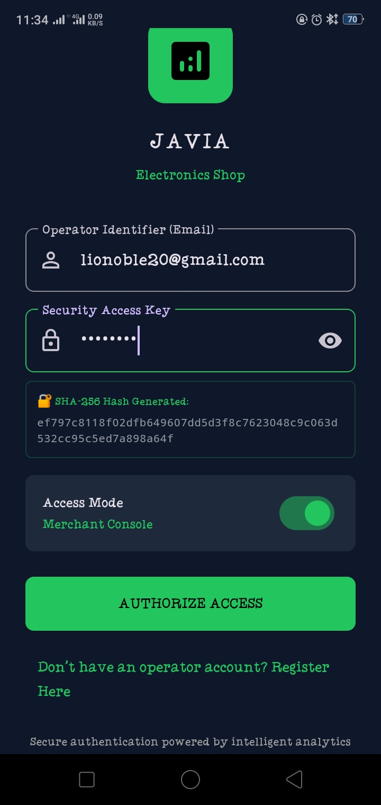
Figure 2: Login screen showing the SHA-256 hash generated in real time as the password is typed, confirming the hashing mechanism is functioning correctly before the credential is ever sent for comparison

Additional Evidence — Products and Sales Data Persistence
The following two screenshots provide direct evidence that the products and sales tables described above are not only structurally defined but actively storing and retrieving real data within the running application, as the logged-in operator "Noelle" under the Merchant Console role.

Figure 3: Live Market Catalog — Products Table in Action
This screenshot shows the Catalog screen reading directly from the products table. Three real product records are displayed — Laptop (KES 40,000, 5 units, Low Stock), TV (KES 30,000, 7 units, Low Stock), and Samsung Tablet (KES 25,000, 14 units, In Stock) — each with a live USD conversion. This confirms the products table is correctly storing structured data (name, category, costPrice/sellingPrice, stockQty) and that the application successfully queries and renders it.

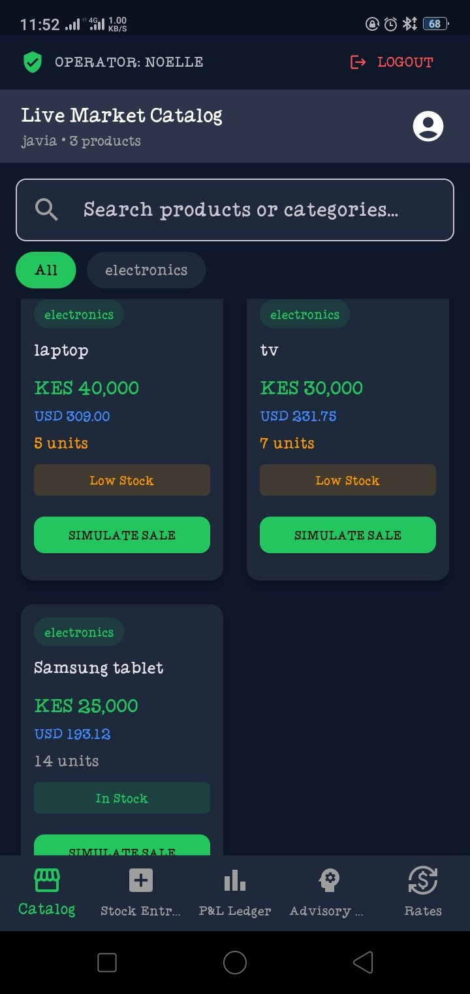
Figure 3: Live Market Catalog screen displaying real product records retrieved from the SQLite products table, confirming successful structured data storage

Figure 4: Real-Time P&L Dashboard — Sales Table in Action
This screenshot shows the P&L Dashboard computing real business metrics directly from the sales table. Monthly Total Revenue of KES 440,000.00 against Total Cost of KES 300,000.00 yields a Realized Margin of 31.8%. The dashboard also demonstrates the foreign key relationship between sales and products by identifying the Best Product (Samsung Tablet) and the product Needing Attention (TV) — both derived by joining sales records back to their corresponding products via the productId foreign key, exactly as described in the Relationships section above.

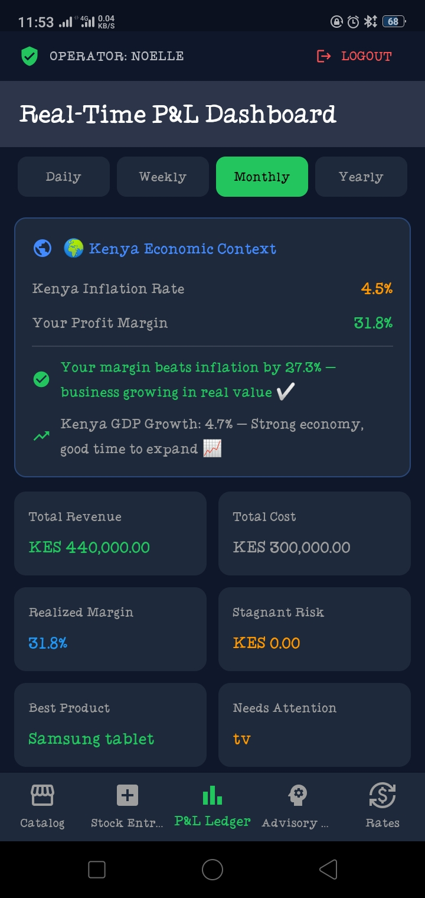
Figure 4: Real-Time P&L Dashboard showing computed revenue, cost, and margin figures derived from real records in the sales table, confirming the products-sales relationship is functioning correctly

Expected Outputs
- A new operator can register with a hashed password stored securely in the users table.
- Returning operators log in using their email and password, which is hashed and matched against the stored hash — plain passwords are never compared or stored.
- Role-based access ensures a Merchant Console user and a Client View user are not interchangeable, even with the same credentials.
- All product and sales data persists in SQLite, surviving app restarts, and feeds directly into the Real-Time P&L Dashboard and Intelligent Advisory Engine built in previous weeks.

